Code Adaptations:

V1 – Baseline
Accuracy: 0.4246
This is the baseline code with 5 random classifications taken.
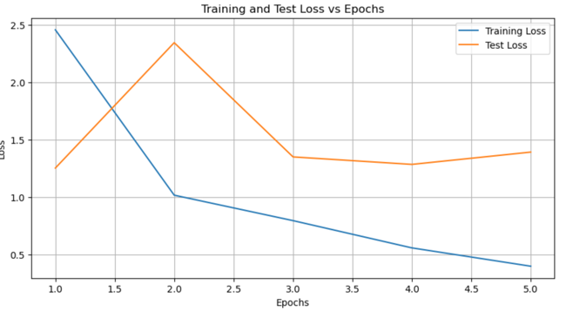
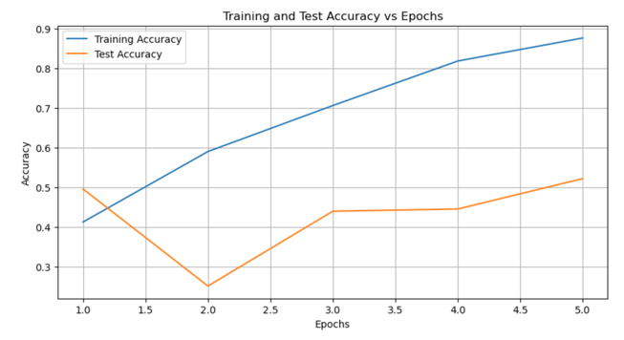
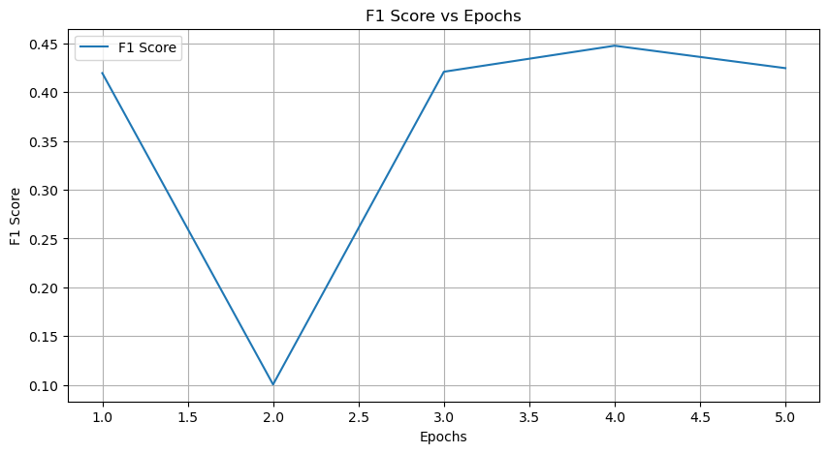

V2 – Increase the number of epochs to 20
Accuracy: 0.5317
Increased the number of epochs to 20 to allow for more computations to occur and hence the model to become more accurate. Increasing the number of epochs allows the model to process the training data multiple times, which can lead to the following improvements and consequently an increase in the F1 score
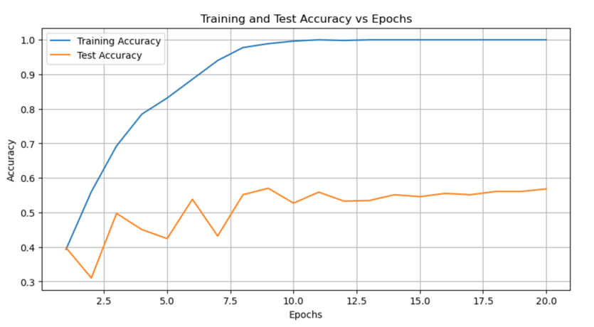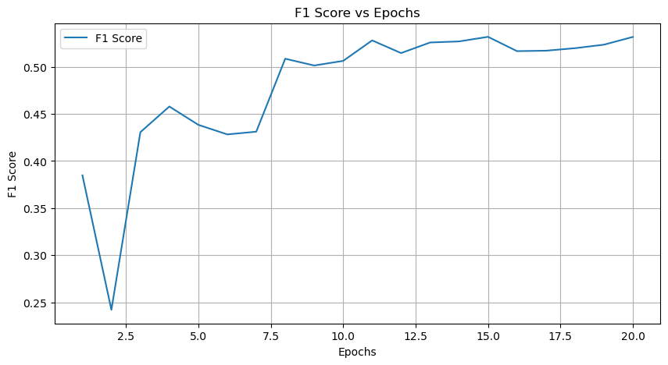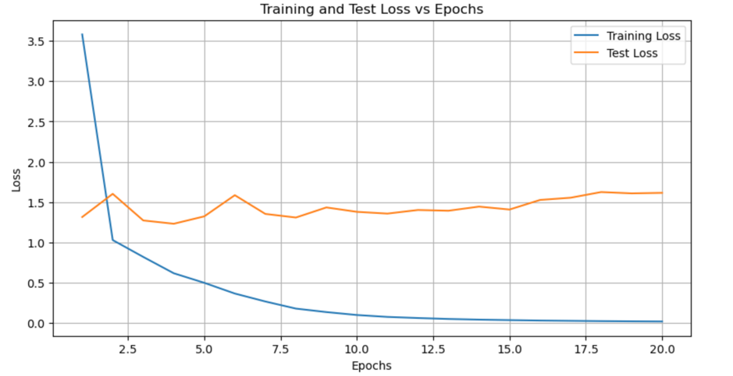

V3 – Selecting the data with largest classification
Accuracy: 0.3842
The change in the code allows the model to be trained on the datasets which have the largest number of images. However, this decreased accuracy due to overfitting e.g. Boeing 737 had 267 images whereas the next closest had 133.

V4 – Increase batch size from 16 to 64
Accuracy: 0.4508

V5 – Revert batch size and make the neural network more complex

